# Project 2 - CS 340 README

## About the Project/Project Title

Grazioso Salvare has hired our team at Global Rain to help them identify dogs that are good candidates for search-and-rescue training. Grazioso Salvare will be working alongside five different animal shelters. Grazioso Salvare wants an application that will help them identify and categorize the available dogs.

## Motivation

The motivation behind the creation of this project is for Grazioso Salvare to help find dogs they can train to rescue humans and other animals.

## Getting Started

1. Enter command center and import csv file aac_shelter_outcomes.csv using Mongo import tools
2. Open the mongo shell and create a simple index and a compound index.
3. Create a user named accuser and a password for the user account.
   1. Provide read/write access for database and read access for database, test.
4. Install python and Jupyter Notebooks in order to start utilizing program.
5. Download the zipped file named CS340 Project 2, which contains the necessary code.
   1. If you wish to recreate the code yourself, please see steps to complete project for basic guidelines.

## Installation

1. Python
2. MongoDB

## Usage

This Python program utilizes CRUD operations to allow the users to add, search, update, and delete animals from the database system using the profile “accuser1.” This program uses a python (.py) file to create the CRUD functionality, connect to the database using pymongo and initialize the MongoClient. The program utilizes the Python driver PyMongo as it makes it easy to work with MongoDB databases and includes an intuitive API for accessing said databases. This program also uses a .ipynb file, which is the dashboard. The dashboard only utilizes the search function from the python file. The .ipynb file uses the Dash framework, which helps build the data visualization interfaces. The dashboard displays the company’s logo, animals’ information, filters to find specific animals that meet certain requirements, a geolocation map, and a pie chart.

### Steps to Complete Project

1. Open terminal.
2. Import the AAC database dataset.
3. Create a user account with a unique username, password and grant the account read write access.
4. Create python file (.py).
   1. Initialize MongoClient to access MongoDB.
   2. Enable CRUD functionality in program.
5. Create .ipynb file.
   1. Import JupyterDash, dash, dashboard components, os routines, plotting routines and AnimalShelter1 (CRUD Python module).
   2. Connect to database via CRUD module (.py file).
   3. Create dashboard layout and view.
   4. Create interactions between components and controller.
6. Run .ipynb file and ensure that program is functioning correctly by testing each function.

### Tests

To test that the dashboard was functioning as it should in this program, the dashboard was deployed, and different functions were interacted with. First, we checked that the overall look of the program was up to standard. Next, the different filters (Water Rescue, Mountain or Wilderness Rescue, Disaster or Individual Tracking, and finally reset (returns all widgets to their original, unfiltered state)) were selected and checked that they worked as required. While selecting the different filters, the data table, and pie chart were looked over to ensure it was displaying the correct data. Finally, from the data table we selected a specific animal and checked that the map displayed the specific animals’ breed, and name. We needed to ensure that all the functions and graphics worked as anticipated and they all did. The tests are shown under the screenshots section.

### Challenges

Most challenges occurred when connecting interactions to components. For example, my pie chart initially only displayed the data from the whole dataset and did not change when filters were selected. This was a simple error to fix. I set the graph to the incorrect variable, once this was changed it functioned correctly. Overall, the challenges faced during this project were easy to overcome.

### Screenshots

Inserting CSV file:



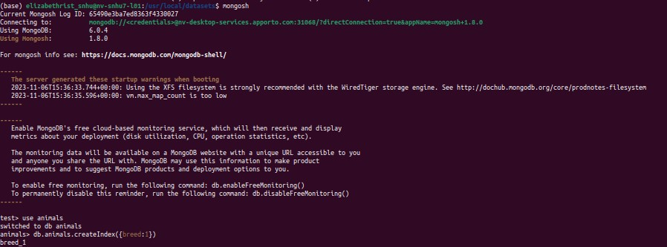

Creating a user account:

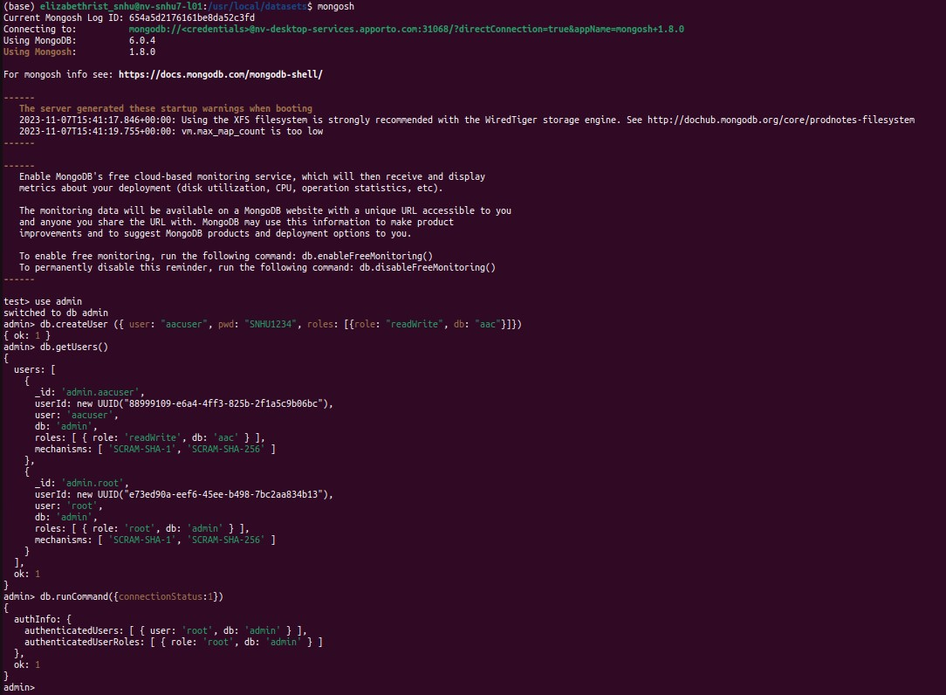



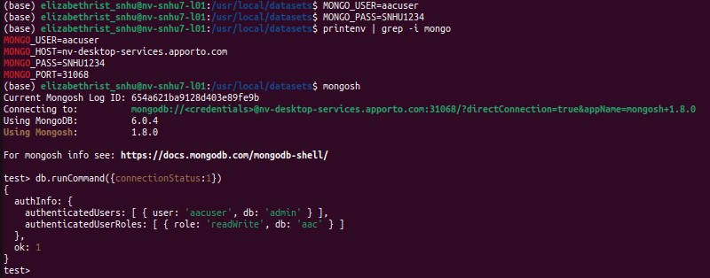

Python file (.py) to access MongoDB databases and enable CRUD functionality:

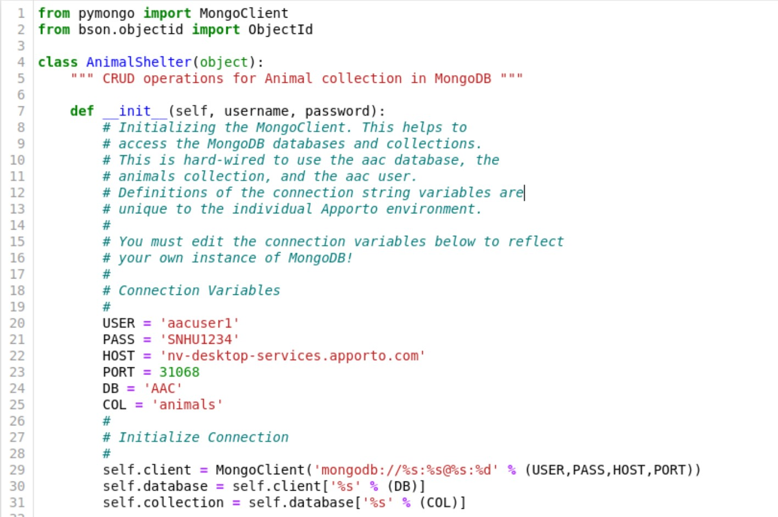

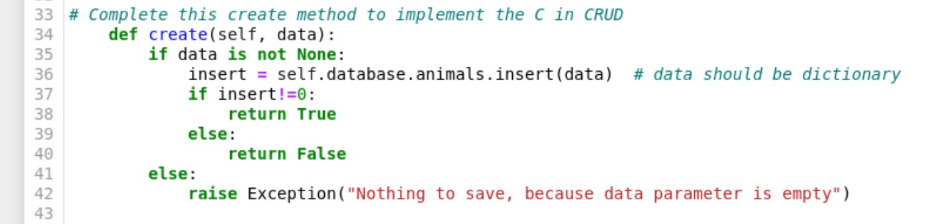

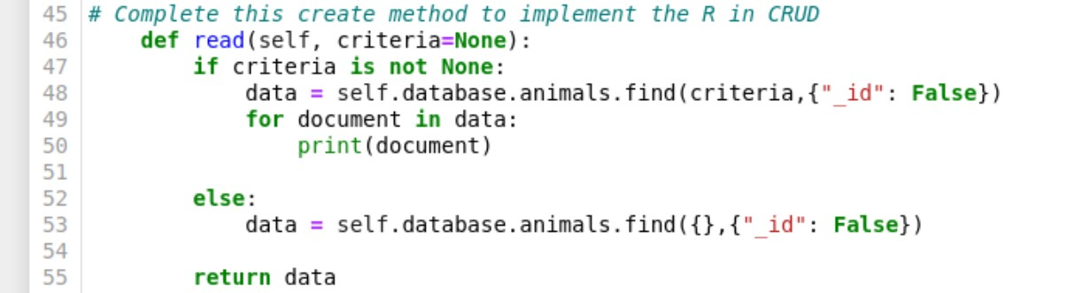

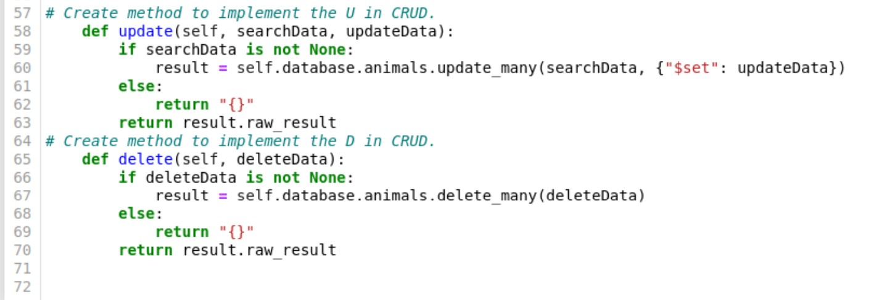

Dashboard tests (functionality):

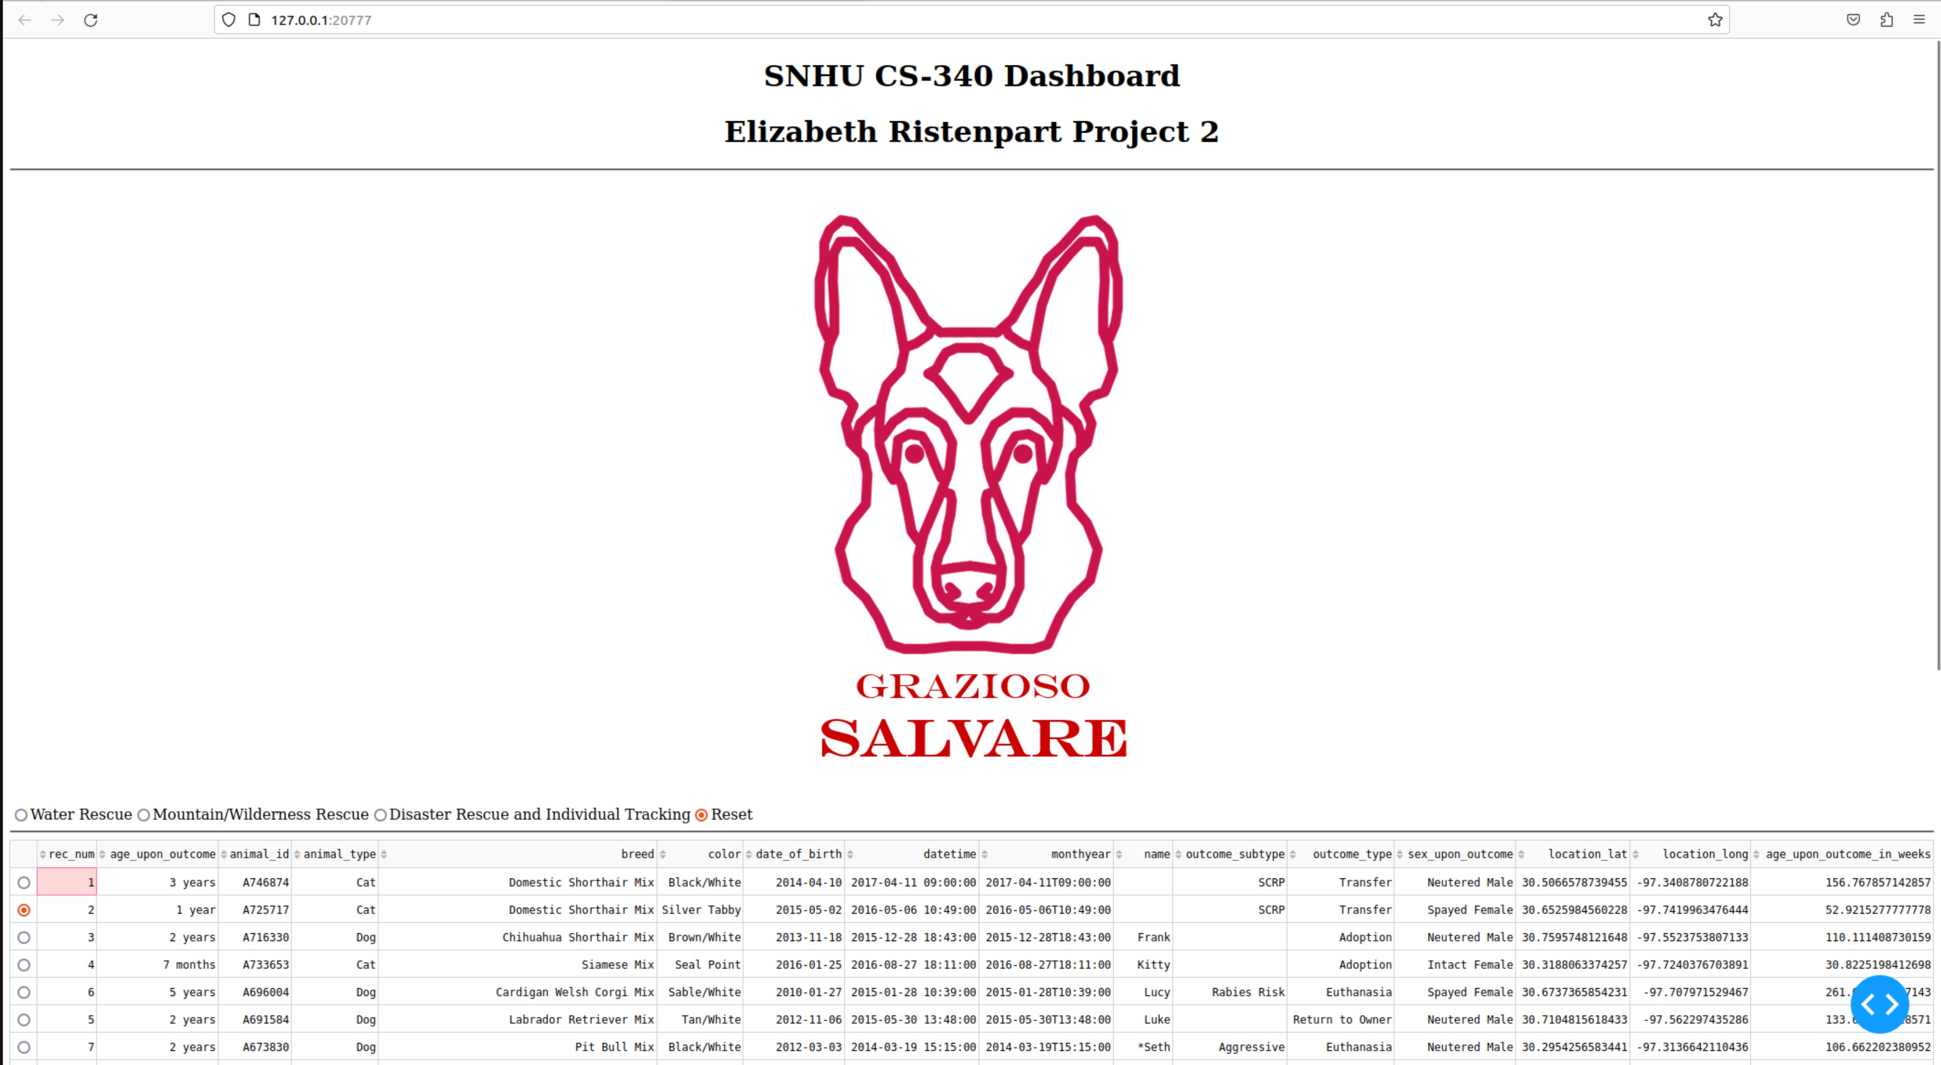

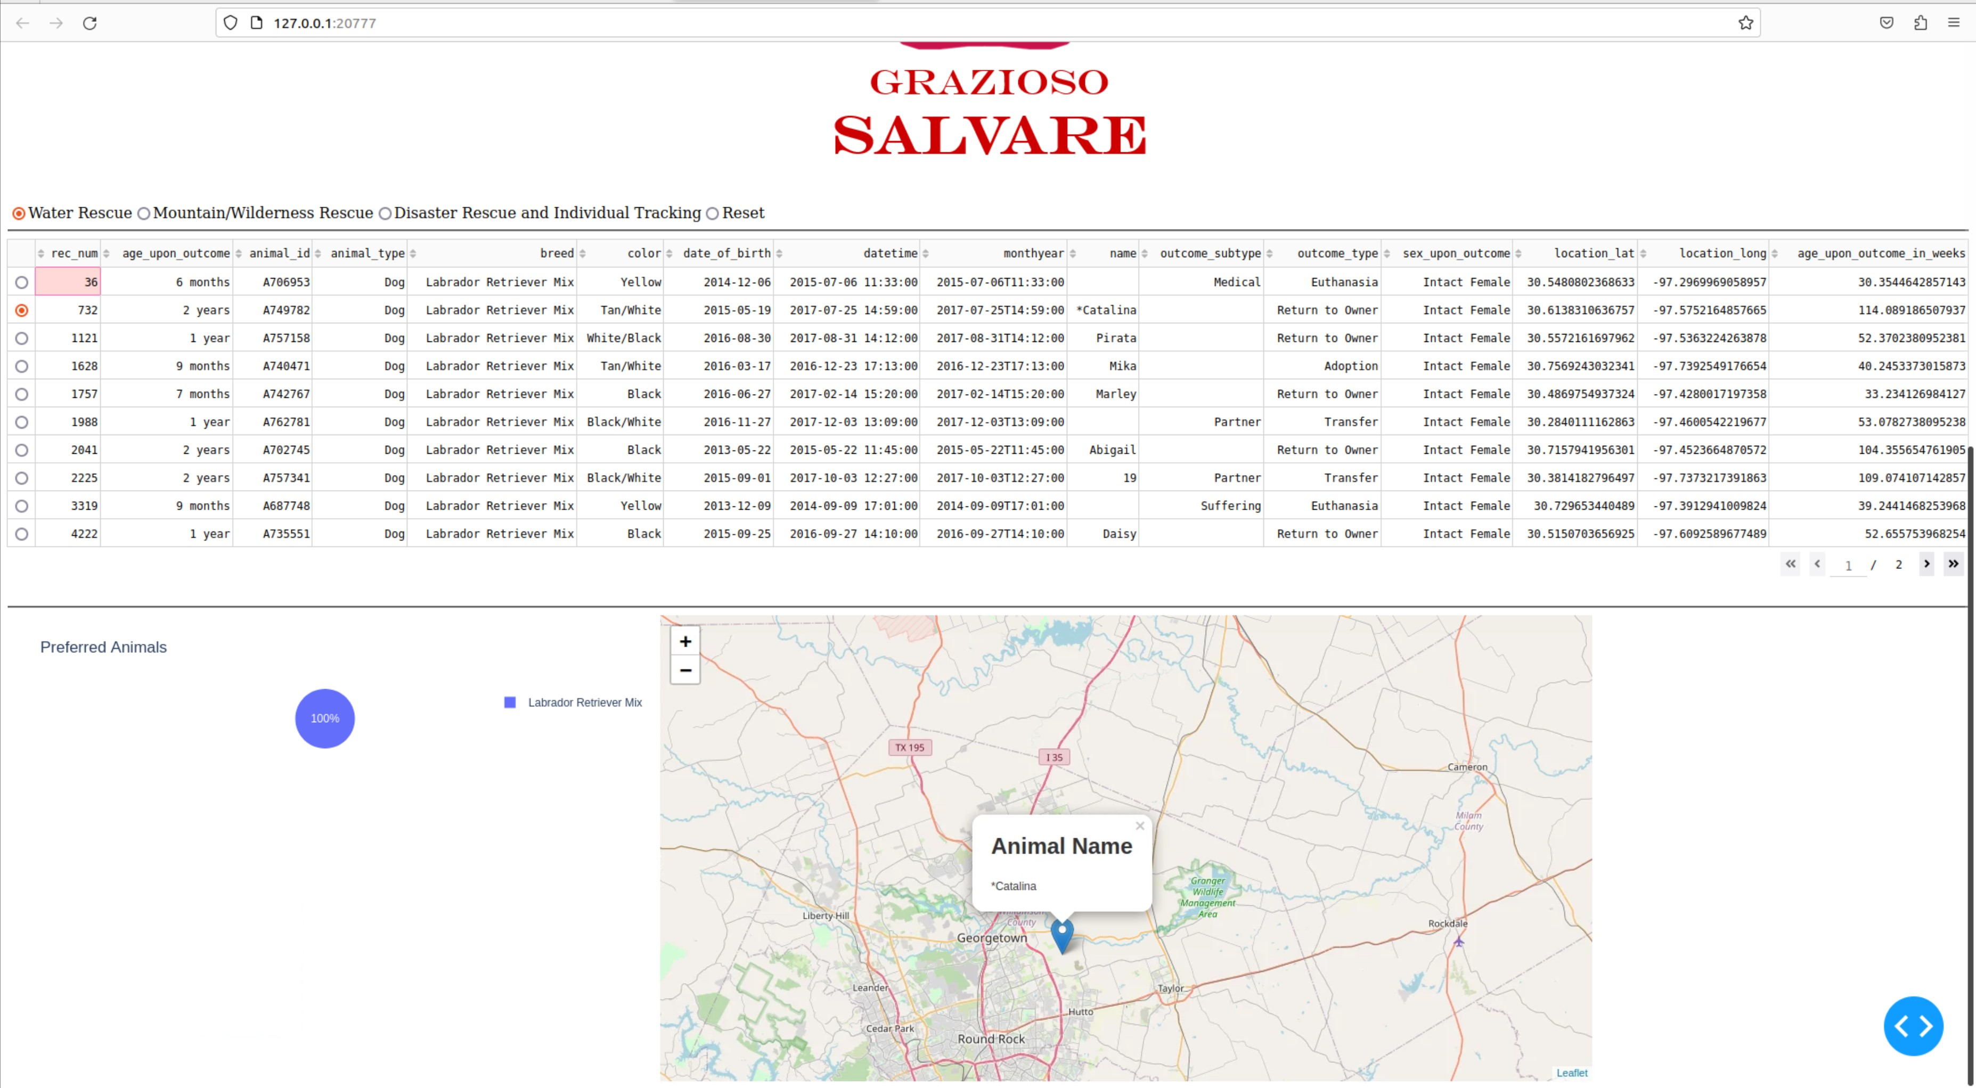

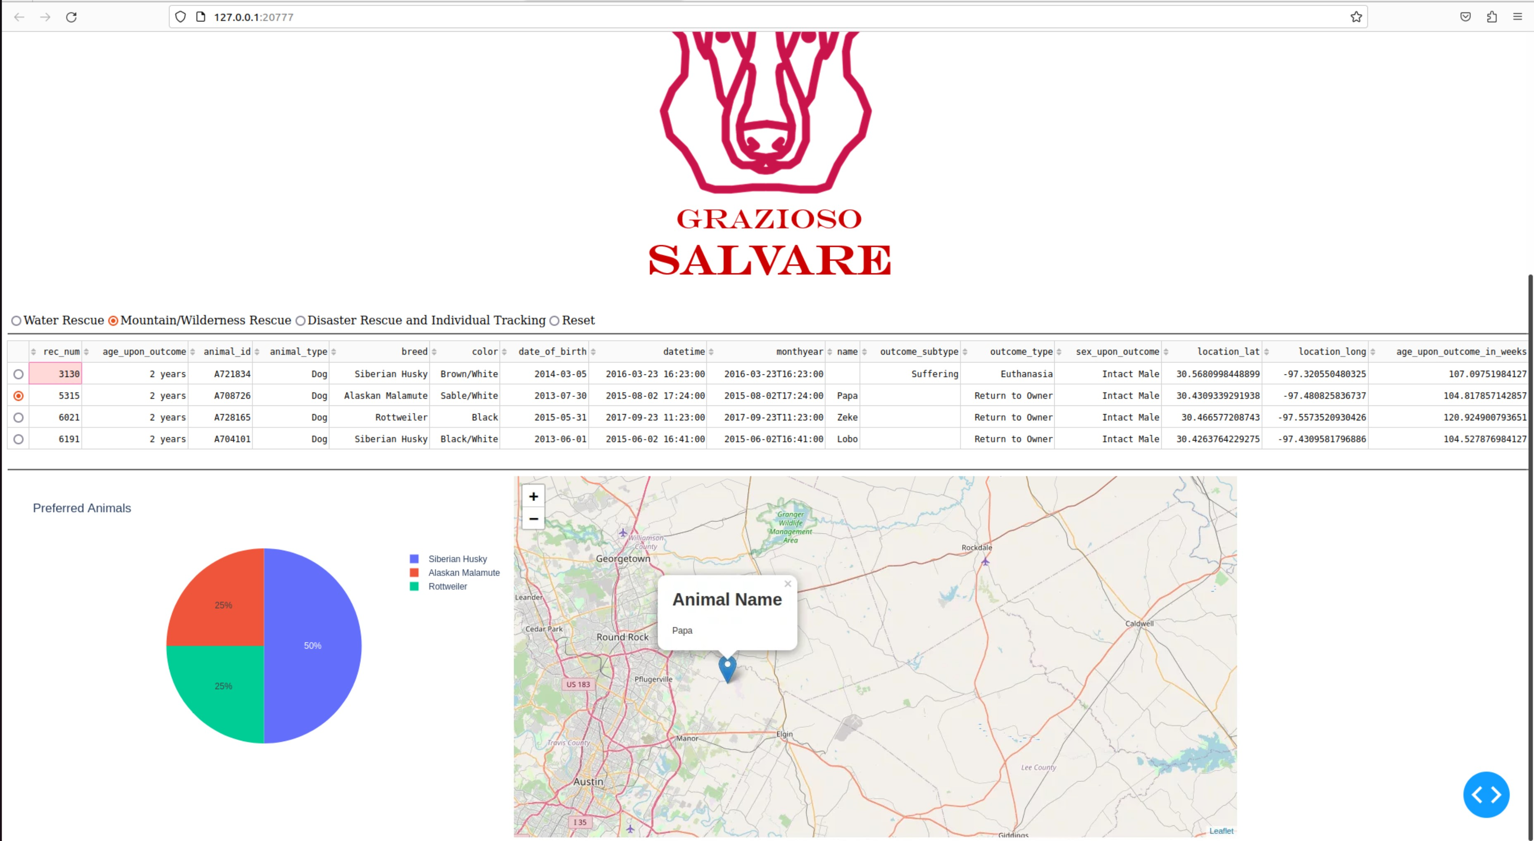

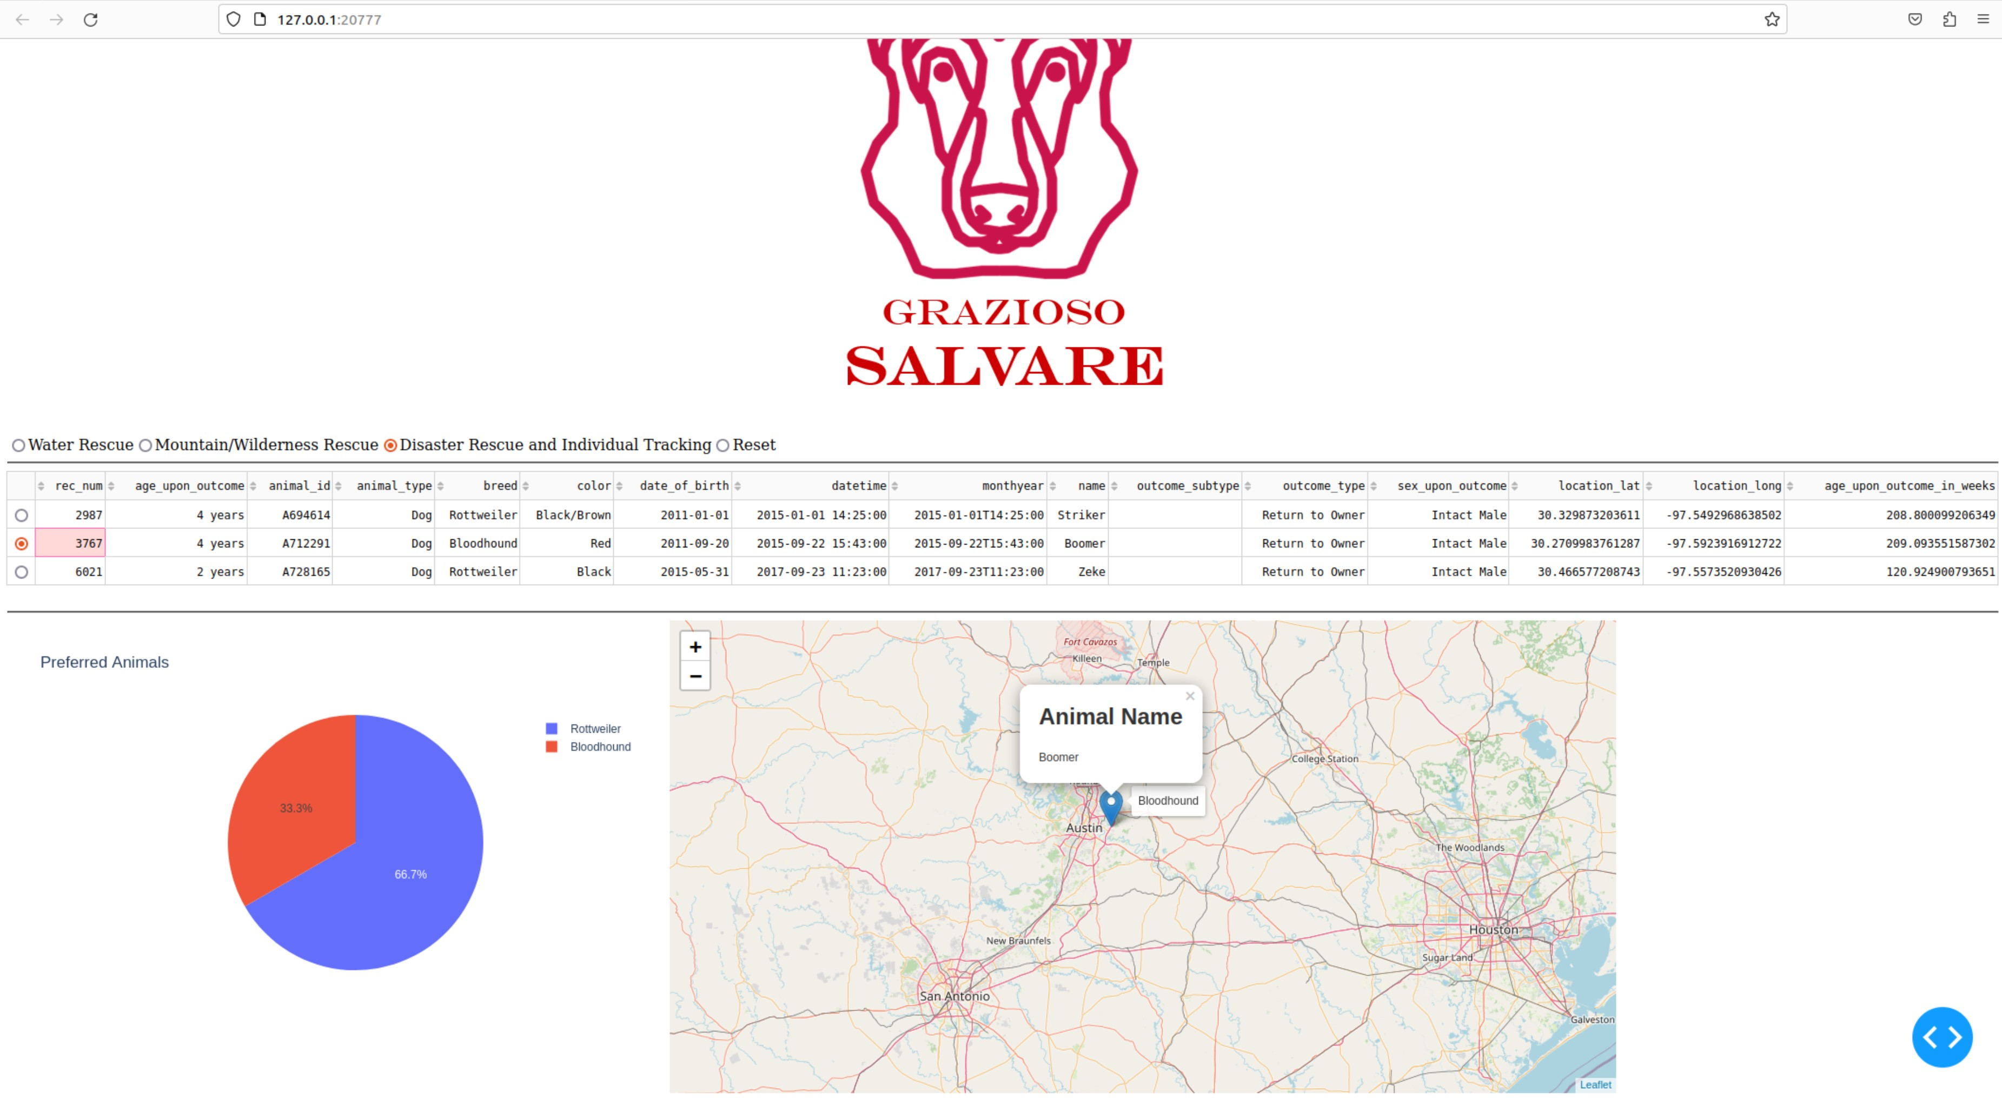

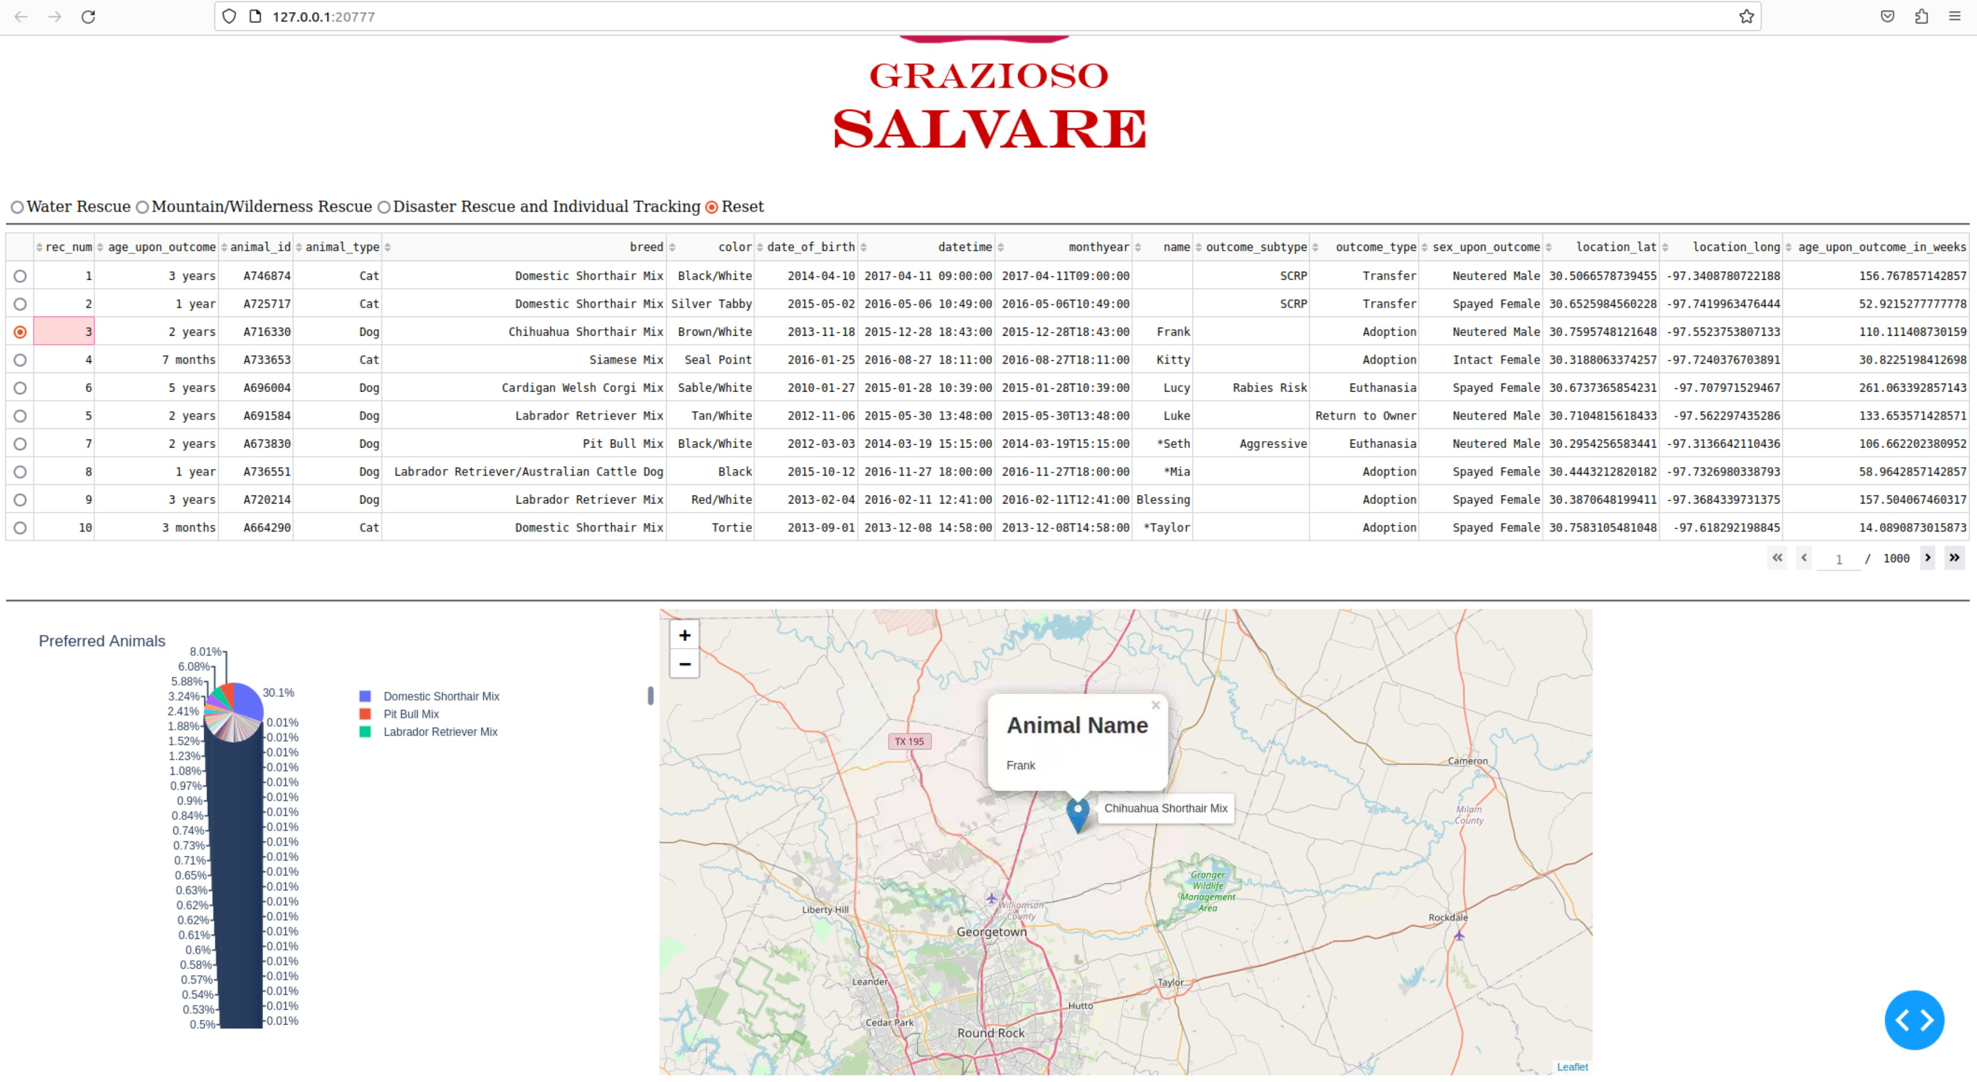

## Contact

Elizabeth Ristenpart